**OUTPUTS**

**GUI**: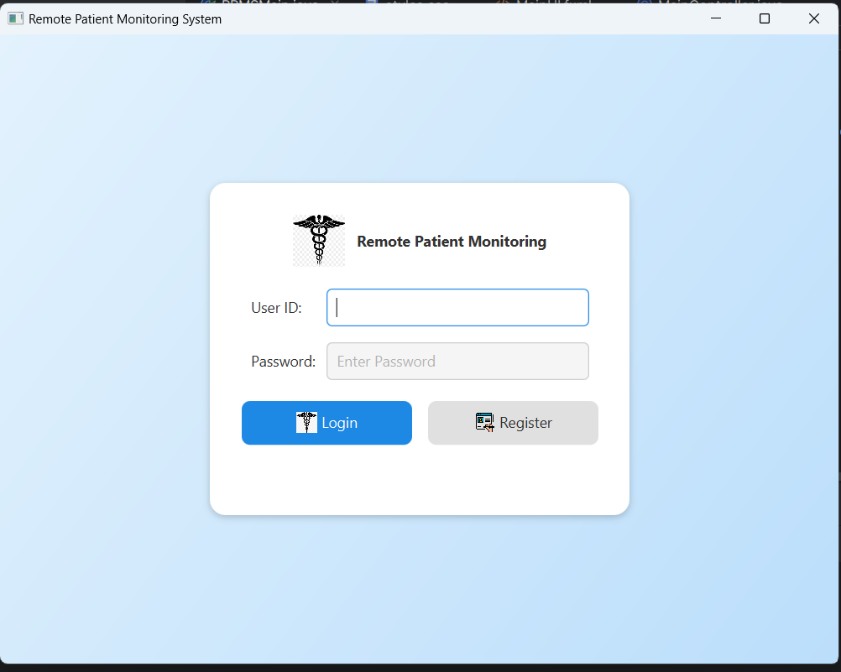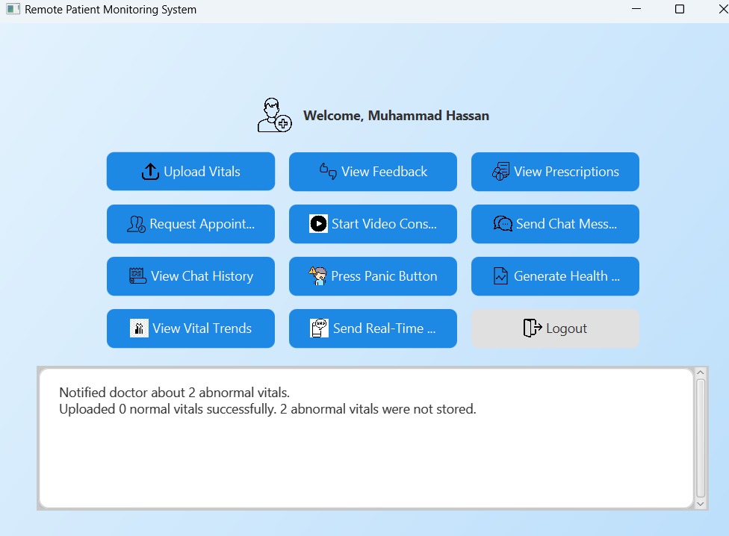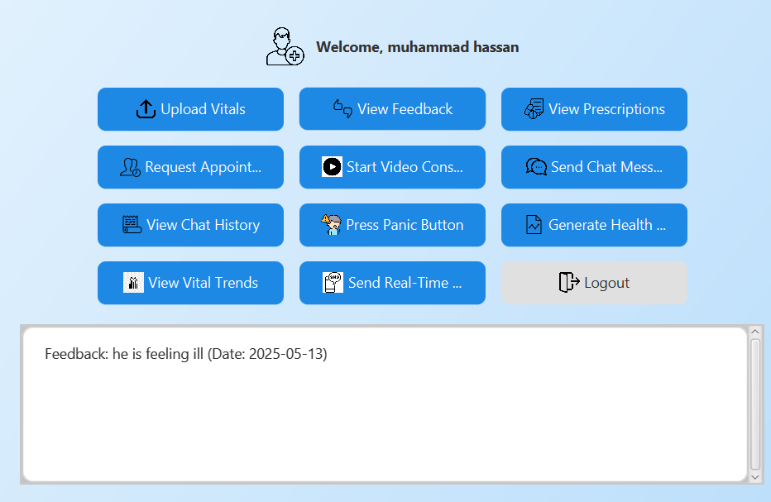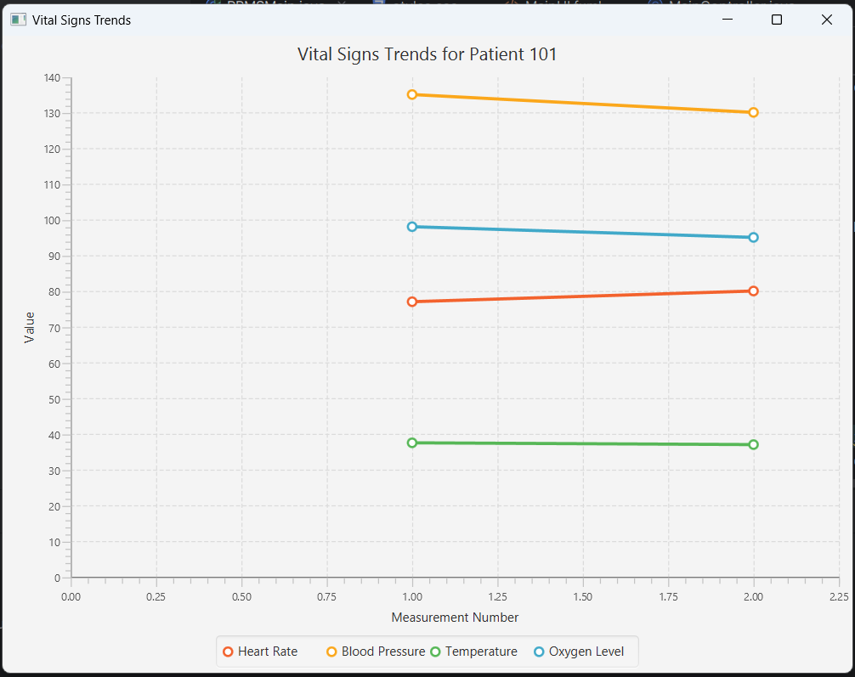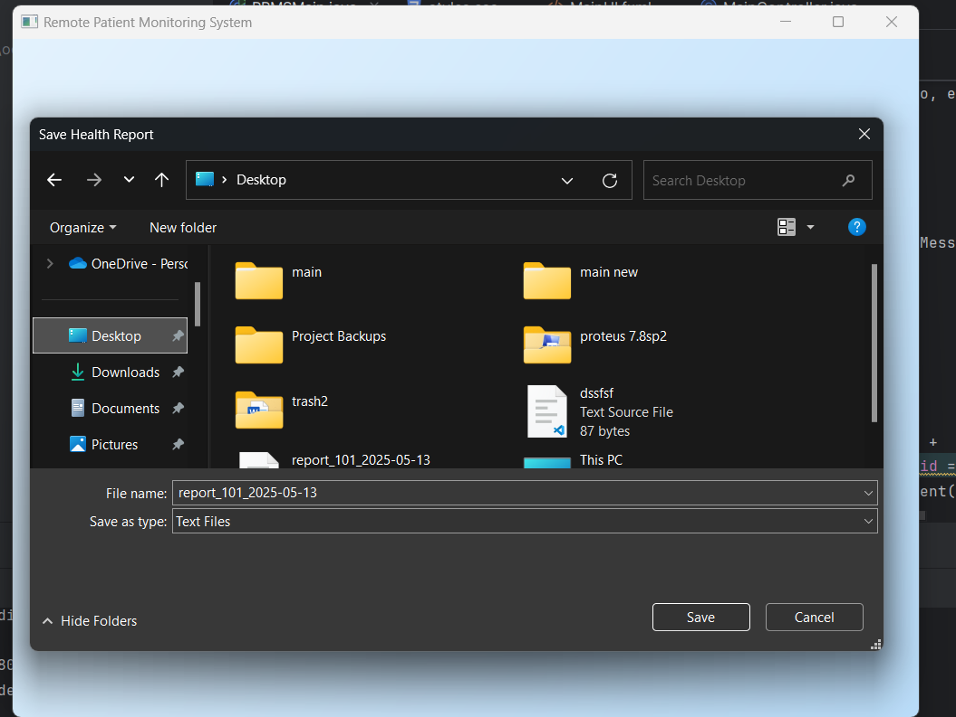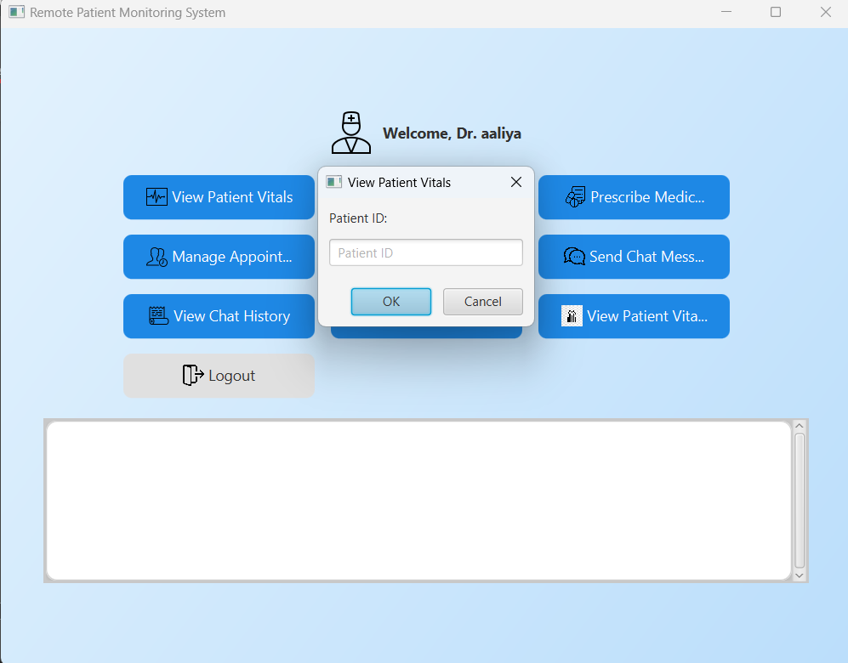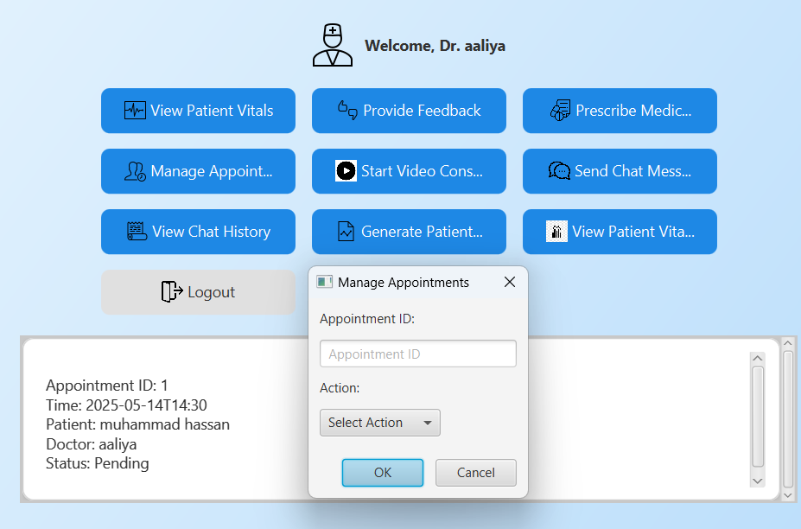

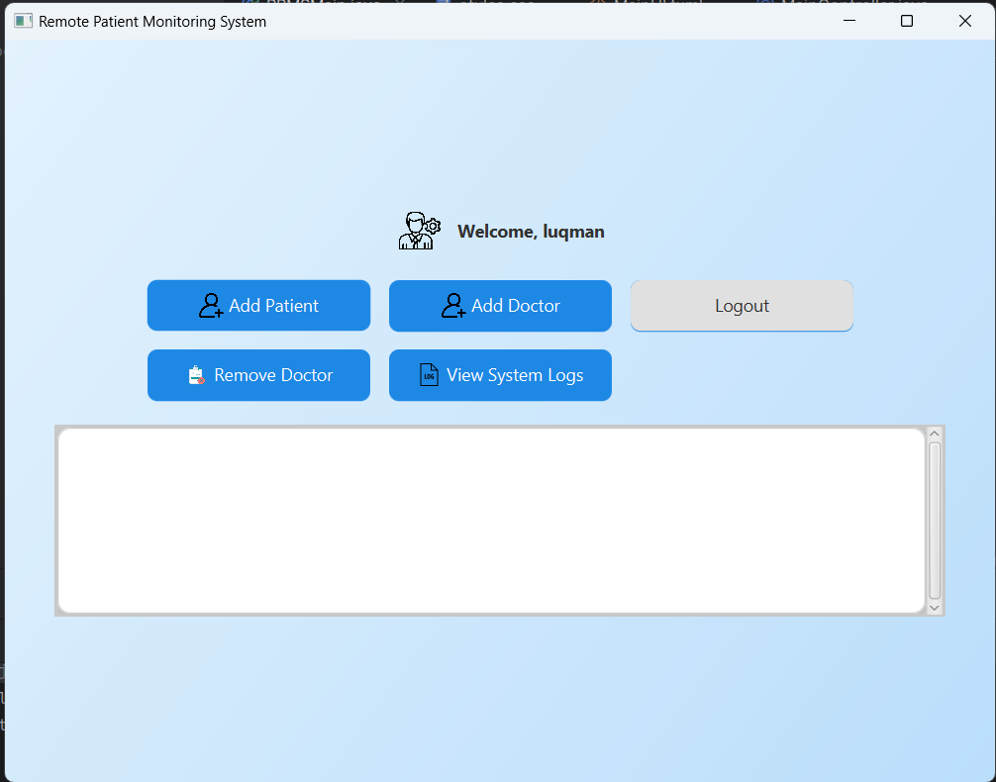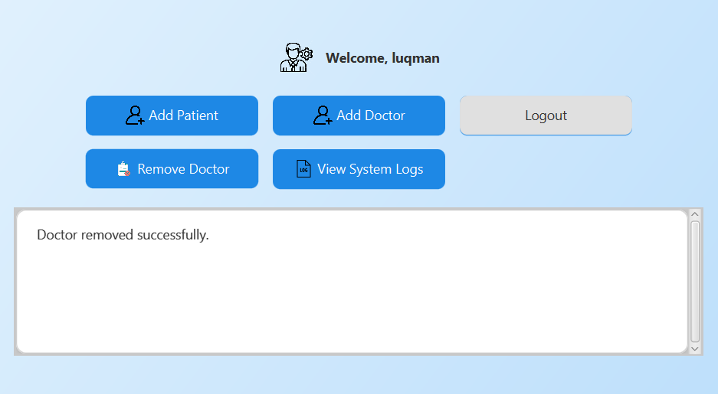

**DATABASE SCHEMA + OUTPUTS**

**SCHEMA:**

CREATE DATABASE hospitalmanagementsystem;

USE hospitalmanagementsystem;

-- Users table: Stores common user information

CREATE TABLE users (

user_id VARCHAR(50) PRIMARY KEY,

name VARCHAR(100) NOT NULL,

contact_info VARCHAR(20) NOT NULL,

gender VARCHAR(10) NOT NULL,

role ENUM('PATIENT', 'DOCTOR', 'ADMIN') NOT NULL,

email VARCHAR(100) NOT NULL UNIQUE

);

-- Patients table: Stores patient-specific information

CREATE TABLE patients (

user_id VARCHAR(50) PRIMARY KEY,

birth_date DATE NOT NULL,

admission_date DATE,

email VARCHAR(100) NOT NULL UNIQUE,

password VARCHAR(255) NOT NULL,

FOREIGN KEY (user_id) REFERENCES users(user_id) ON DELETE CASCADE

);

-- Doctors table: Stores doctor-specific information

CREATE TABLE doctors (

user_id VARCHAR(50) PRIMARY KEY,

joining_date DATE NOT NULL,

specialization VARCHAR(100) NOT NULL,

email VARCHAR(100) NOT NULL UNIQUE,

password VARCHAR(255) NOT NULL,

FOREIGN KEY (user_id) REFERENCES users(user_id) ON DELETE CASCADE

);

-- Administrators table: Stores administrator-specific information

CREATE TABLE administrators (

user_id VARCHAR(50) PRIMARY KEY,

password VARCHAR(255) NOT NULL,

joining_date DATE NOT NULL,

FOREIGN KEY (user_id) REFERENCES users(user_id) ON DELETE CASCADE

);

-- Appointments table: Stores appointment details

CREATE TABLE appointments (

appointment_id BIGINT PRIMARY KEY AUTO_INCREMENT,

appointment_time DATETIME NOT NULL,

patient_id VARCHAR(50) NOT NULL,

doctor_id VARCHAR(50) NOT NULL,

status ENUM('Pending', 'Approved', 'Canceled') NOT NULL DEFAULT 'Pending',

FOREIGN KEY (patient_id) REFERENCES patients(user_id) ON DELETE CASCADE,

FOREIGN KEY (doctor_id) REFERENCES doctors(user_id) ON DELETE CASCADE

);

-- Vitals table: Stores patient vital signs

CREATE TABLE vitals (

vital_id BIGINT PRIMARY KEY AUTO_INCREMENT,

patient_id VARCHAR(50) NOT NULL,

checkup_date DATE NOT NULL,

heart_rate DOUBLE NOT NULL,

blood_pressure DOUBLE NOT NULL,

body_temperature DOUBLE NOT NULL,

oxygen_level DOUBLE NOT NULL,

FOREIGN KEY (patient_id) REFERENCES patients(user_id) ON DELETE CASCADE

);

-- Feedback table: Stores feedback from doctors to patients

CREATE TABLE feedback (

feedback_id BIGINT PRIMARY KEY AUTO_INCREMENT,

patient_id VARCHAR(50) NOT NULL,

doctor_id VARCHAR(50) NOT NULL,

date DATE NOT NULL,

comments TEXT NOT NULL,

FOREIGN KEY (patient_id) REFERENCES patients(user_id) ON DELETE CASCADE,

FOREIGN KEY (doctor_id) REFERENCES doctors(user_id) ON DELETE CASCADE

);

-- Prescriptions table: Stores prescription details

CREATE TABLE prescriptions (

prescription_id BIGINT PRIMARY KEY AUTO_INCREMENT,

patient_id VARCHAR(50) NOT NULL,

medication VARCHAR(100) NOT NULL,

dosage VARCHAR(50) NOT NULL,

schedule VARCHAR(100) NOT NULL,

FOREIGN KEY (patient_id) REFERENCES patients(user_id) ON DELETE CASCADE

);

-- Messages table: Stores chat messages between users

CREATE TABLE messages (

message_id BIGINT PRIMARY KEY AUTO_INCREMENT,

sender_id VARCHAR(50) NOT NULL,

receiver_id VARCHAR(50) NOT NULL,

message TEXT NOT NULL,

timestamp DATETIME DEFAULT CURRENT_TIMESTAMP,

FOREIGN KEY (sender_id) REFERENCES users(user_id) ON DELETE CASCADE,

FOREIGN KEY (receiver_id) REFERENCES users(user_id) ON DELETE CASCADE

);

-- Video Consultations table: Stores video call details

CREATE TABLE video_consultations (

call_id BIGINT PRIMARY KEY AUTO_INCREMENT,

doctor_id VARCHAR(50) NOT NULL,

patient_id VARCHAR(50) NOT NULL,

scheduled_time DATETIME NOT NULL,

meeting_link VARCHAR(255) NOT NULL,

FOREIGN KEY (doctor_id) REFERENCES doctors(user_id) ON DELETE CASCADE,

FOREIGN KEY (patient_id) REFERENCES patients(user_id) ON DELETE CASCADE

);

-- System Logs table: Stores system activity logs

CREATE TABLE system_logs (

log_id BIGINT PRIMARY KEY AUTO_INCREMENT,

action VARCHAR(255) NOT NULL,

log_date DATE NOT NULL

);

**OUTPUTS:**

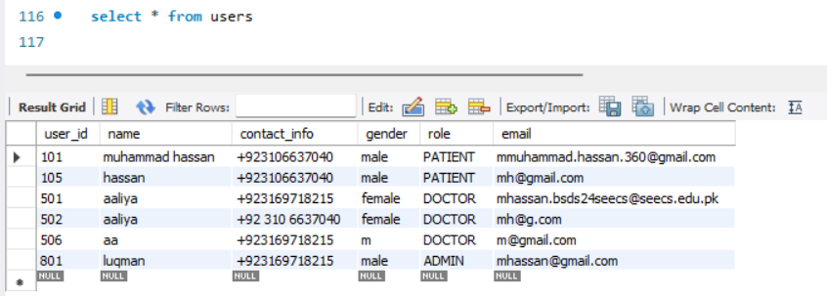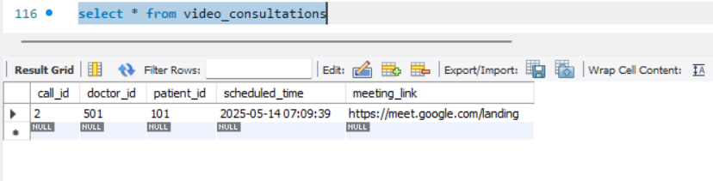

**EMAILS:**

**ABNORMAL VITALS IN CSV**



